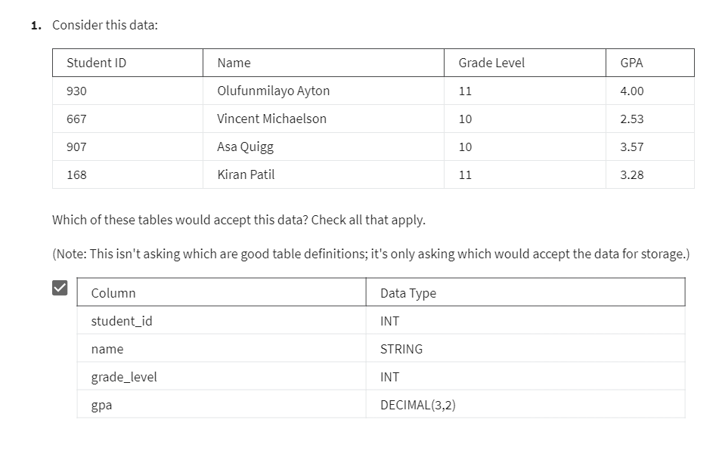

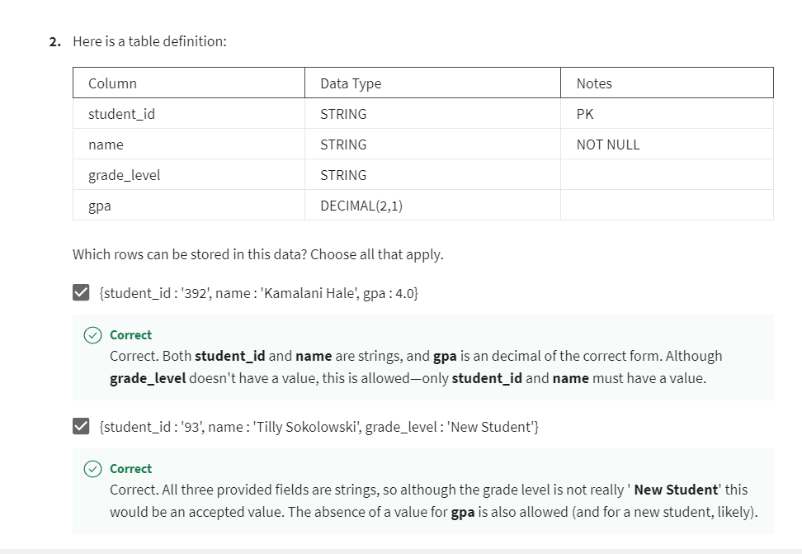

Question 3

What is database normalization?

Designing the tables in your relational database so that redundant storage is minimized and the chance of inconsistencies in the data is also reduced.

Question 4

Which of the following rules are well-known conditions that help define third normal form? (Note, we are stating the rules a bit informally.) Choose all that apply.

The non-key columns of a table must be dependent on the key only. For example, if you have an employee table with employee id as the key, then you might have a department id column for the employee, but not department name also (because the department name would be dependent on the department id, which is not your table's primary key).

Every table in your database must have a primary key.

There must be no repeating groups in any table. For example, you will not have a column that can contain one or more phone numbers.

Question 5

Which of the following are *costs* of normalization? Choose all that apply.

Normalizing a database requires more complex queries on your data to answer many questions.

Normalizing a database design generally will make your queries run less efficiently.

Question 6

Why might you find it helpful to denormalize your database design? Choose all that apply.

If you frequently query some summary data, like store daily sales totals, keeping a summary table reduces the need to recompute summaries.

In a system where join processing is slower, denormalizing can improve the runtime speed of many queries and reports.

Denormalizing will "pre-join" your previously normalized tables and store them that way, so fewer joins are needed in your queries.

Question 7

Which of these accurately describe why features of operational databases are not needed for analytic databases?

Analytic databases often use data collected from other sources (including other operational databases), so enforcing business rules is typically not needed.

Analytic databases update infrequently so ETL (extract, transform, and load) utilities can replace many of the DML features of operational databases.